
LRD Security bonnet release cable guard.
Thank you for buying the LRD Security cable guard, this is what the guard prevent thieves from doing:
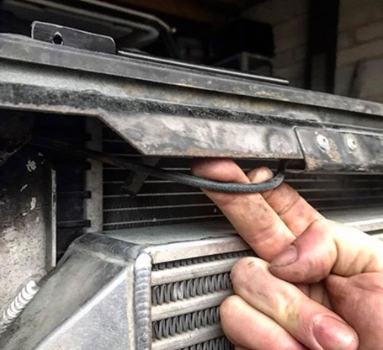
To install this guard, you will need:
1 x Small philips screwdriver
1 x Large Philips screwdriver
1 x Drill
1 x Rivet Gun
4 x Rivets (Supplied)
1 x 7mm socket with short extention bar
Step 1
Remove your front grill, if you have AC (this component fits both AC and none AC models) there are two large screws on the side of the front panel. Then there are four smaller screws at the top of the grill into the slam panel.
For non AC models there are six large screws in the grill, you will then need to remove the grill. On each side of the surround there are bolts, that bolt it to the wings, these need to be removed as well, and then finally the four screws along the top.
Step 2
Release cable from the old cable guard with the 7mm socket, through this hole in the slam panel
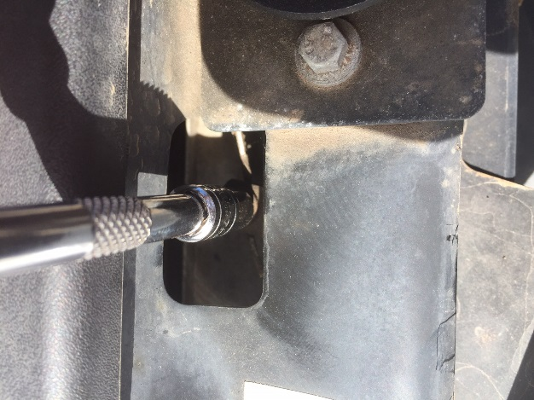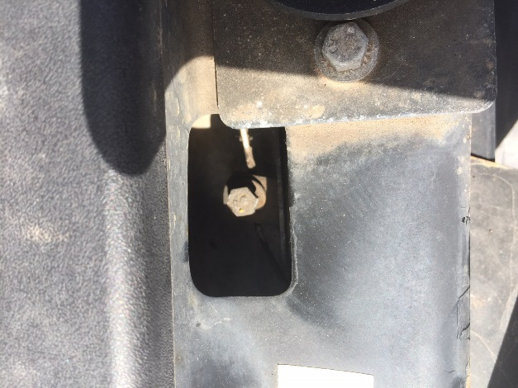
Step 3
Drill out the four rivets on the front of the old guard
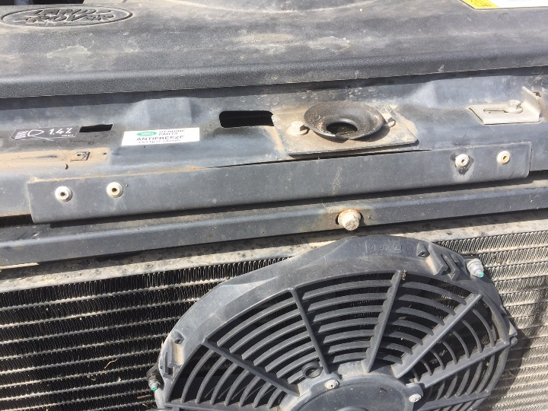

Step 4
Remove guard, and remove the cable securing bolt, replacing it on the new guard, so as not to lose it. However don’t tighten it up at this stage

Step 5
Rivet new guard in place
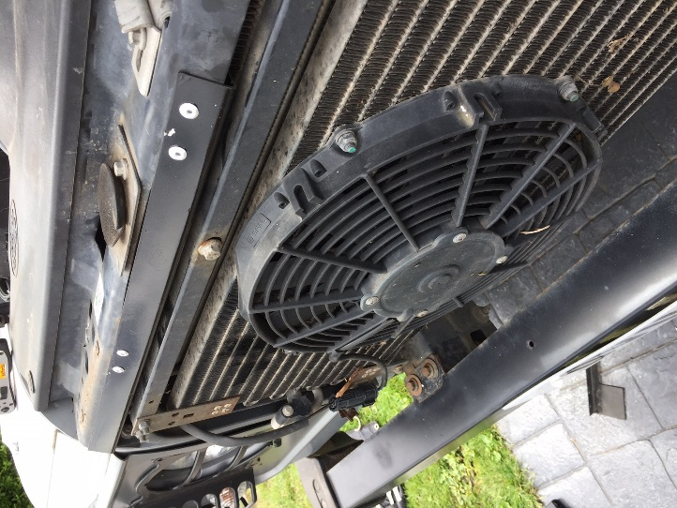

Step 6
Tighten up cable on new guard, ensuring that there is no slack, so that you can open the bonnet up when needed! Refit surround and grill in the reverse order of the above.

